BALLYMAHON MUNICIPAL DISTRICT

Corporate Affairs,
Aras an Chontae,
LONGFOIRT.

18th February 2016.

To: Each Member of Ballymahon Municipal District.

Dear Member,

You are requested to attend Meeting of Ballymahon Municipal District to be held in
Ballymahon Community Library on Thursday, 25th February 2016 at 4.00 p.m. to transact business, as set out on the Agenda hereunder.

Yours sincerely,
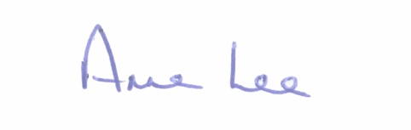

_______________
Anne Lee,
Meetings Administrator.

AGENDA

Prayer before meeting.

- Consideration of 2016 – 2018 Multi-Annual Restoration Improvement Programme – report enclosed.

- Consideration of Schedule of Ballymahon Municipal District Works 2016 -
report enclosed.

::::::::::::::::::::::::::::::::::

